Social science Worksheet Chapter22 Government

1.Match the following

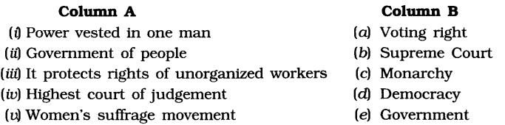
2.State true or false
a. The decision of the Indian govt. to maintain peaceful relations with Russia is taken by the total government.
b. The decision to locate a common well in a village is taken by the central government.
c. The decision to introduce a new 1000 rupees note was taken by the state government.
3.What do governments do for their people?
(a) Build the roads and schools (b) Supply the electricity
(c) Take action on social issues (d) All of these
4.What is an important part of the government?
(a) Courts (b) Private organizations
(c) Public schools (d) Parliament
5.At which level does a government work?
(a) Local level (b) National level
(c) State level (d) All of these
6.Which of the following is the capital of India?
(a) Mumbai (b) Agra
(c) New Delhi (d) Aurangabad
7.On which level does the Indian Government take the decision to maintain peaceful relations with U.S.S.R.?
(a) Local level (b) State level
(c) Central level (d) None of these
8.What does the Government make for everyone to follow?
(a) Laws (b) Decisions
(c) Relations (d) None of these
9.Which type of government is chosen by the people?
(a) Democratic Government (b) Dictatorship
(c) Monarchy Government (d) None of these
10.What is a Monarchy government?
(a) Chosen by the people (b) Ruled by the King or Queen
(c) Both (a) and (b) (d) None of these

Read the following advertisement and answer the questions.
Nowhere in the world have governments willingly shared power. All over Europe and USA, women and the poor have had to fight for participation in government. Women’s struggle to vote got strengthened during the First World War. This movement is called the women’s suffrage movement as the term suffrage usually means right to vote.

During the War, many men were away fighting, and because of this women were called upon to do work that was earlier considered men’s work. Many women began organizing and managing different kinds of work. When people saw this they began to wonder why they had created so many unfair stereotypes about women and what they were capable of doing. So women began to be seen as being equally capable of making decisions.
The suffragettes demanded the right to vote for all women and to get their demands heard they chained themselves to railings in public places. Many suffragettes were imprisoned and went on hunger strikes, and they had to be fed by force. American women got the right to vote in 1920 while women in the UK got to vote on the same terms as men some years later, in 1928.
- Where and who had to fight for participation in government?
- When did women’s struggle get strengthened?
- Why was this struggle called the women's suffrage movement?
- Why were women called to work in men’s fields during the war?
- Why were women seen as being equally capable of making decisions?
- Who were suffragettes?
- When did American women get the right to vote?
- When did UK women get voting rights equal to men?

